README Document:

Steps to generate data:

1. Test pcap file tcp_test.pcap is provided in the git repo. This file is created by using following command.

tcpdump -qns 0 -X -r ./pcap_splits/test_split_00000_20170704115332.pcap tcp -w ~/tcp_test.pcap

1. once p4 switch is started (sudo p4run), run below command to replay the pcap file

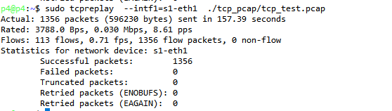

1. there is a counter named packet_counter just to cross check the number of packets received at p4 swtich. Cross check the number of packets with tcpreplay output.

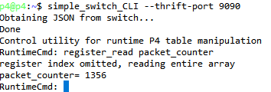

1. run the script reg_copy.sh is available in git repo. This script copies the registry counters to .csv files.
2. P4_data_prep.ipynb notebook attaches all .csv files produced in above step and creates a single p4_metrics.csv
3. For comparison, there is a CICFlowmeter generated metrics file tcp_test.pcap_Flow.csv is available.

